Task- 1
You should spend about 20 minutes on this task.
The three pie charts below show the changes in annual spending by local authorities in Someland in 1980, 1990 and 2000.
Summarize the information by selecting and reporting the main features, and make comparisons where relevant. Write at least 150 words.

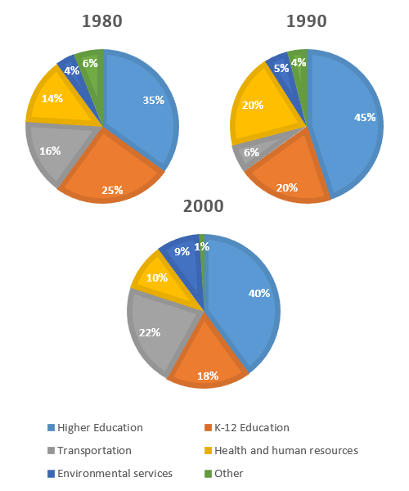

Task-02
You should spend about 40 minutes on this task.
Some people believe that competition helps children to be better prepared for their future, while others say that competition can be harmful to children and should be limited to adults.
Discuss both views and give your opinion.

Task-01
You should spend about 20 minutes on this task.
You have been staying in a foreign country for the last two years, and your visa is about to expire next June. However, you are planning to take a three-months professional course. You will need a visa extension.

Write a letter to the consular in the embassy and ask for an extension on your visa.
Write at least 150 words.
You do NOT need to write any addresses.
Begin your letter as follows:
Dear Sir or Madam,

Task-02
You should spend about 40 minutes on this task.
Some people believe that competition helps children to be better prepared for their future, while others say that competition can be harmful to children and should be limited to adults.
Discuss both views and give your opinion.
Give reasons for your answers and provide relevant example and experience you might have.
Write at least 250 words.

